HUMANOID

**Project Third Increment**

**Team Number:** 12

Sri Sai Narayana Ram Gopal Mangena (23)

Achyuth Reddy Nalamadgu (25)

**Project Objectives**

**Significance/Uniqueness:**

The significance of this application is that it provides real life view of human anatomy and it also features the interactions with the application. This application helps in exploring more features of human anatomy in simple way using voice commands, gestures and gazes from the user based on deep learning concepts, through which we train the model. Our main aim is to provide the real life view of human anatomy with interaction features in Microsoft HoloLens.

**System Features:**

* Experience the spatial view of human body.
* Users can easily understand the complex human system.
* Can access instantly, just by wearing the head mounted device.
* Users can control the application by using gestures.
* Users can interact with application by voice commands.
* Users can also see the visualization of real time user data extracted

**Approach**

**Data Source:**

**3D models:** We will collect the 3D models of human body from the internet. Major source of 3D models is clara.io, which provides the real-time models for free. Also by using existing objects, we can develop complex models in Unity 3D.

**Real-time data:** Fitbit smart watch, which provides the data of an individual for the daily activity. Various activities of individual include number of steps, heart rate, number of floors he climbed, number of calories he burned, distance he traversed.

**Tools:**

* Unity 3D
* Microsoft Visual Studio

**Expected Inputs/Outputs:**

**Input:** Major source of input for this application is the real-time data that includes heartbeat, location, weight, sleep data.

**Expected Output:** Application displays real-time view of human anatomy along with the real- time data in the form of charts and graphs.

**Algorithms:**

**Deep Learning:** We will be using deep learning to train our application to respond to voice commands by user. After training and testing with separate sets, application would be able to respond to the voice commands from the users.

**Related Work**

**Open Source Projects:**

* There are many applications in the field of medicine using Augmented Reality. Following are some of them.
  + AccuVein: Helps doctors to identify patients’ veins.
  + VR Dentist: dental app for educational purposes.
  + Anatomy 4D: Visualizes detailed bone structures.
* By understanding the working of these applications, we want to develop an application that provides real time experience and interaction features to application.

**Application Specification:**

1. **System Specification:**

**Architecture Diagram:**

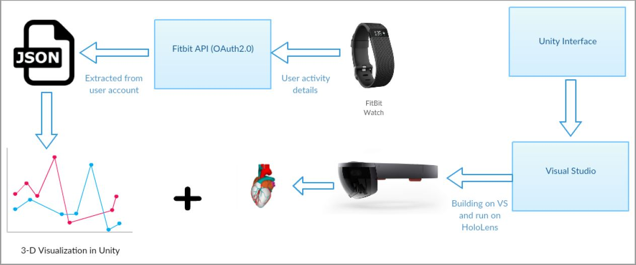

1. **Machine Learning Algorithms:**

To perform the Machine Learning algorithm, we need a data set, so we selected the 1988 coronory disease study is given in the [UCI Machine Learning Heart Disease Dataset](http://archive.ics.uci.edu/ml/datasets/Heart+Disease). Data was collected at the Cleveland Clinic from 303 patients with and without heart disease.

The collected data was randomly split into 70% training and 30% testing. There were a total of 76 attributes in the data set, but for the feasibility purpose we considered on 14 attributes. The following table shows the 14 attributes.

|  |  |  |
| --- | --- | --- |
| S.No | Attribute | Description |
| 1 | Age | Age in years |
| 2 | Sex | Gender 1=male, 0=female |
| 3 | CP | Chest pain,  -- Value 1: typical angina  -- Value 2: atypical angina  -- Value 3: non-angina pain  -- Value 4: asymptomatic |
| 4 | Trestbps | Resting blood pressure (in mm Hg on admission to the hospital) |
| 5 | Chol | serum cholestoral in mg/dl |
| 6 | Fbs | fbs: (fasting blood sugar > 120 mg/dl) (1 = true; 0 = false) |
| 7 | Restecg | restecg: resting electrocardiographic results  -- Value 0: normal  -- Value 1: having ST-T wave abnormality (T wave inversions and/or ST elevation or depression of > 0.05 mV)  -- Value 2: showing probable or definite left ventricular hypertrophy by Estes' criteria |
| 8 | Thalach | maximum heart rate achieved |
| 9 | Exang | exercise induced angina (1 = yes; 0 = no) |
| 10 | Oldpeak | oldpeak = ST depression induced by exercise relative to rest |
| 11 | Slope | the slope of the peak exercise ST segment  -- Value 1: upsloping  -- Value 2: flat  -- Value 3: down sloping |
| 12 | Ca | number of major vessels (0-3) colored by flourosopy |
| 13 | Thal | 3 = normal; 6 = fixed defect; 7 = reversable defect |
| 14 | Num | diagnosis of heart disease (angiographic disease status)  -- Value 0: < 50% diameter narrowing  -- Value 1: > 50% diameter narrowing |

Here we performed Linear Regression model for the data set to retrieve the correlation between the attributes.

1. **Existing applications/services used:**

* Fitbit OAuth2.0 for authorization, to access Fitbit data.
* Fitbit API using developer account- <https://dev.fitbit.com/apps/oauthinteractivetutorial>
* Chrome browser for parsing the data

**Implementation**

**FitBit Data Extraction:**

We register an application on Fitbit developer account, and provide the necessary information as required. Once we register we get the - OAuth 2.0 Client ID, Client Secret as shown below

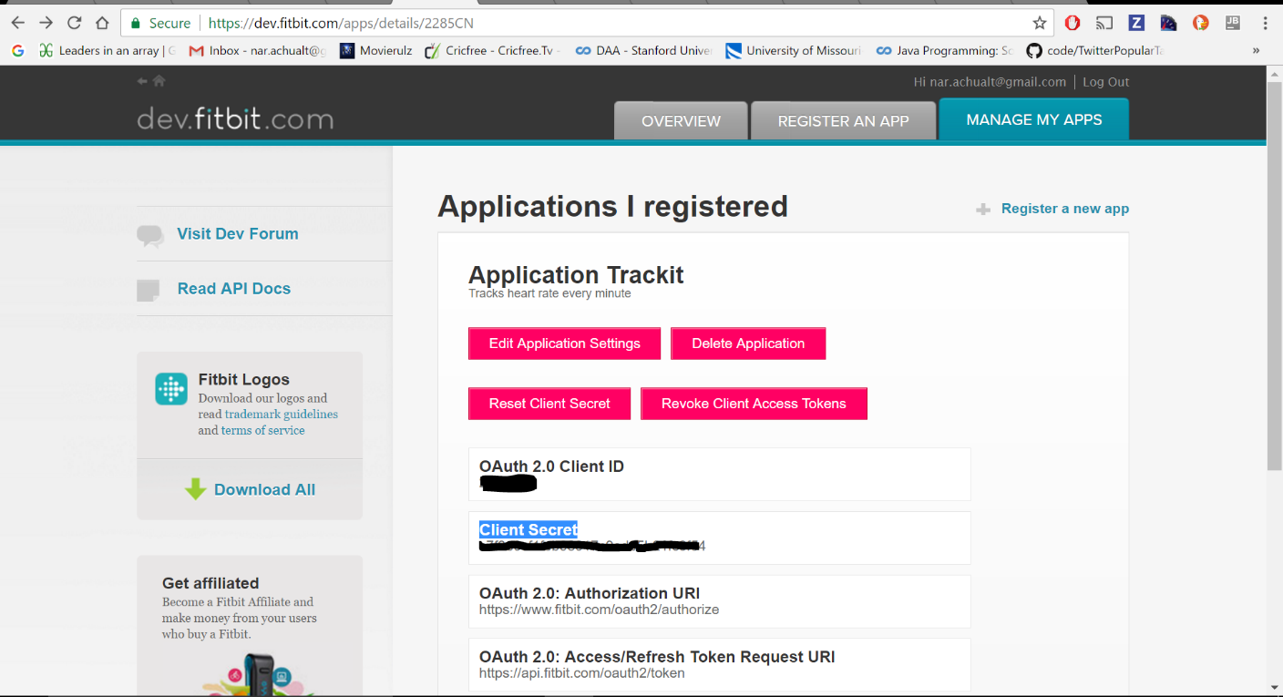

Once we click on the OAuth 2.0 tutorial page we will see the screen below, fill up Client ID, secret key and redirected URI and select the required parametres for the data you want to extract. Here we extracted the data for heart rate.

Then we click on the url generated as shown in Img 3, then we parse the url in text box provided, next we proceed to make request through ‘Send to Hurl.it’ option as shown in Img 4. Then we give our crendentials and allow the application to access our account, then the JSON forrmat is displayed.

Then we convert the JSON format data to CSV.

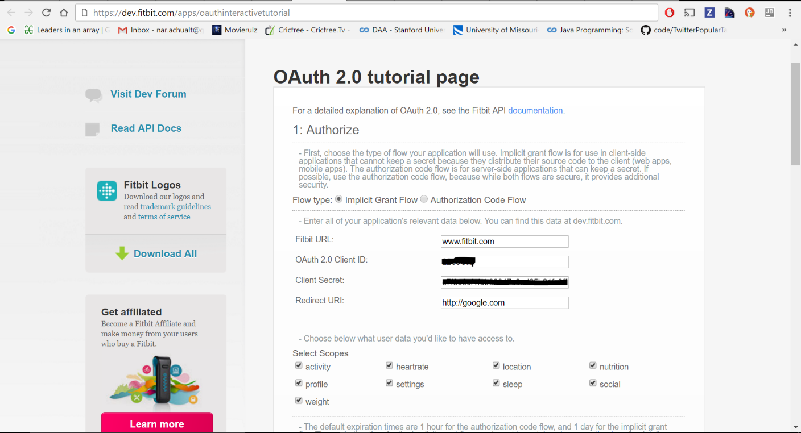

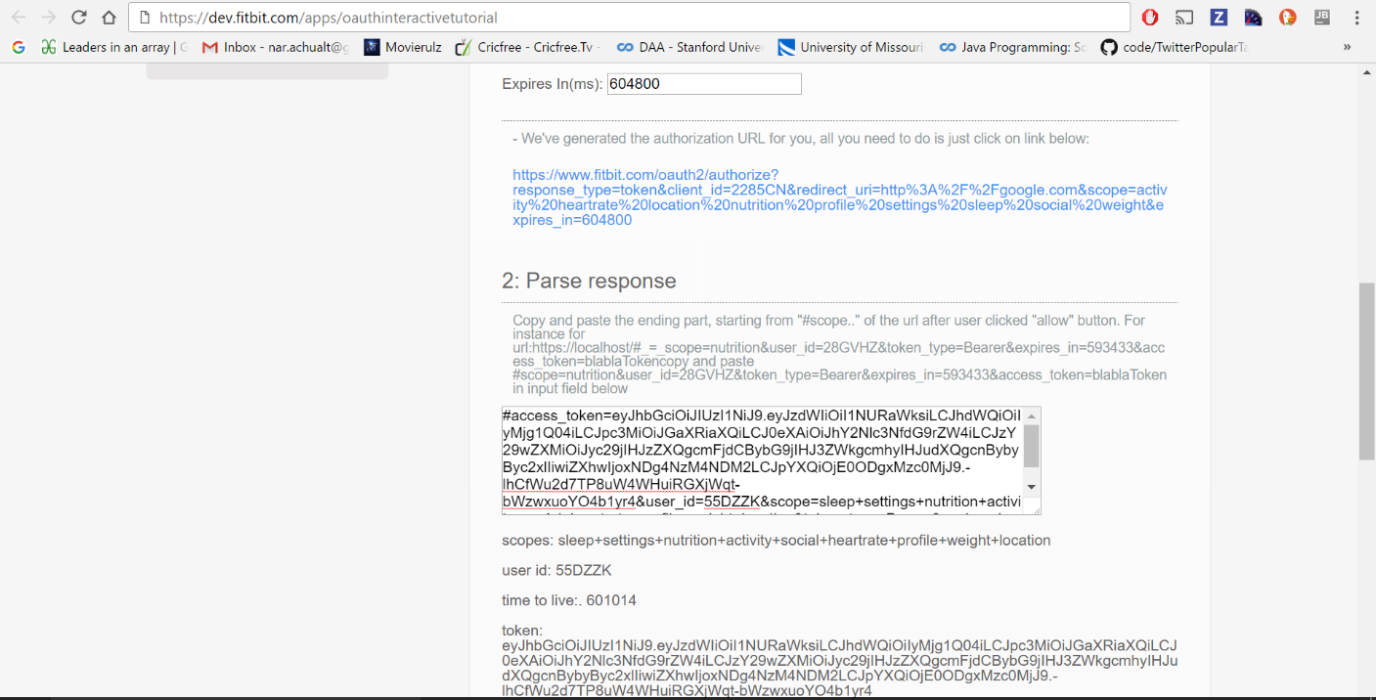

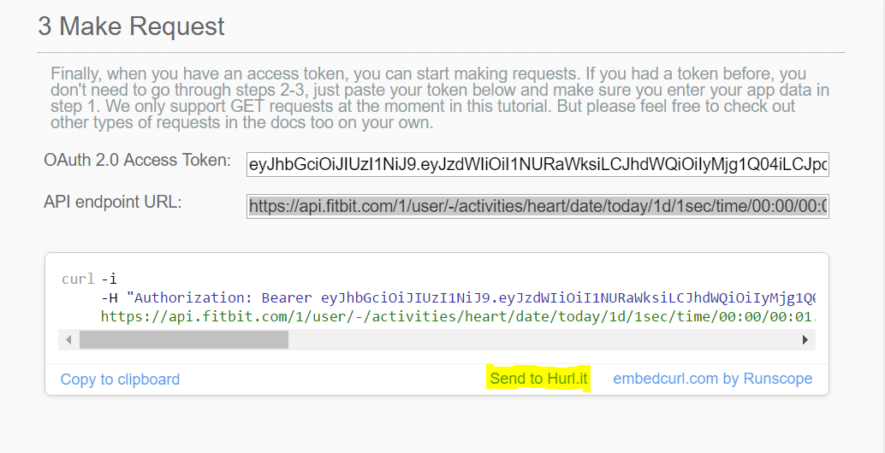

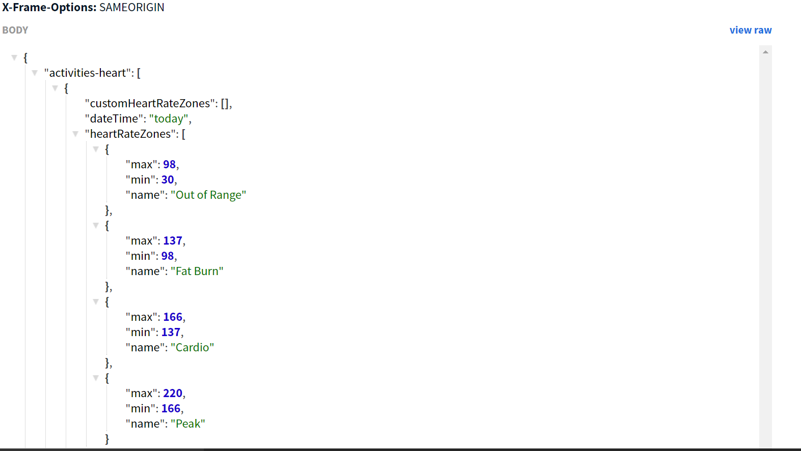

The extracted data is saved in csv file. 

**Phase-2:**

In this phase we ran Linear Regression algorithm on the dataset and tried get correlation between various attributes. Following screen shots show the results of our model built.

This is the heart data with 14 attributes in the txt format.

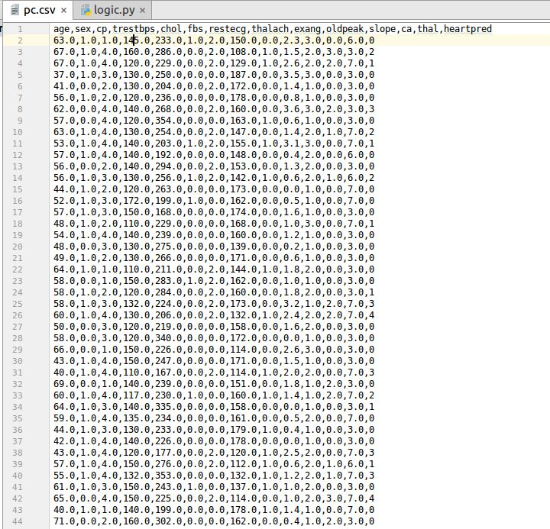

The below screen shot shows the accuracy got from running Linear regression model.

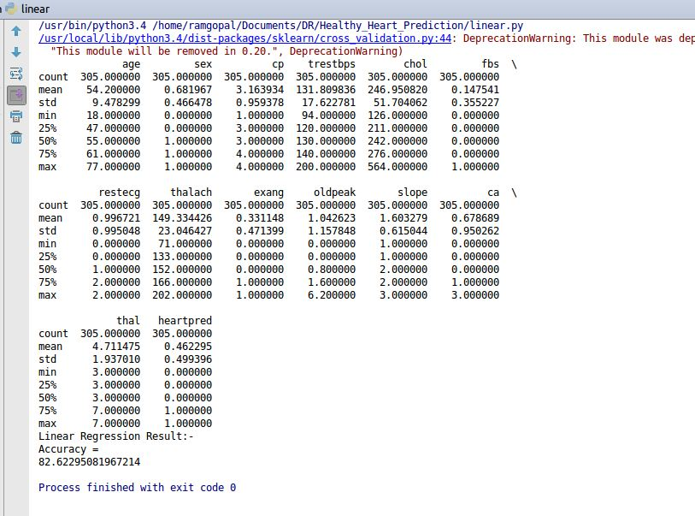

The below screen shot shows the accuracy for dataset using Logistic Regression model. Here the accuracy reported is 83%.

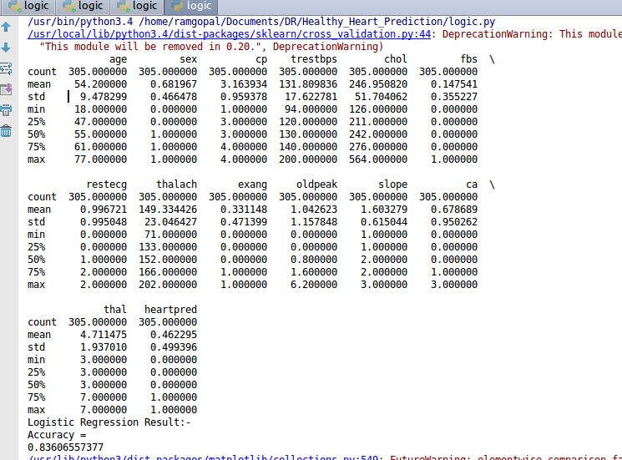

The below result shows us the accuracy reported for only two attributes using Logistic Regression model, and the accuracy reported here is 56%.

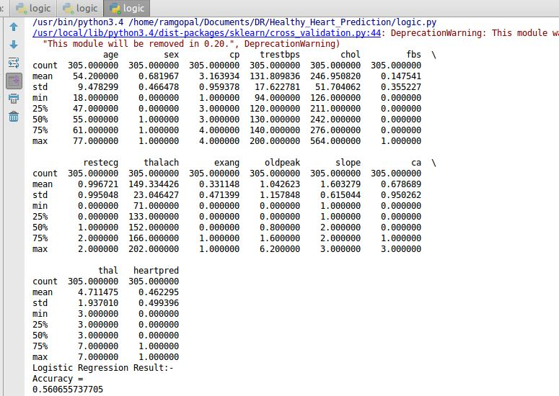

The below graph shows the scatter plot for healthy and unhealthy heart based on two attributes cholostral and fasting blood sugar.

The second scatter plot shows the correlation between all the attributes from the dataset.

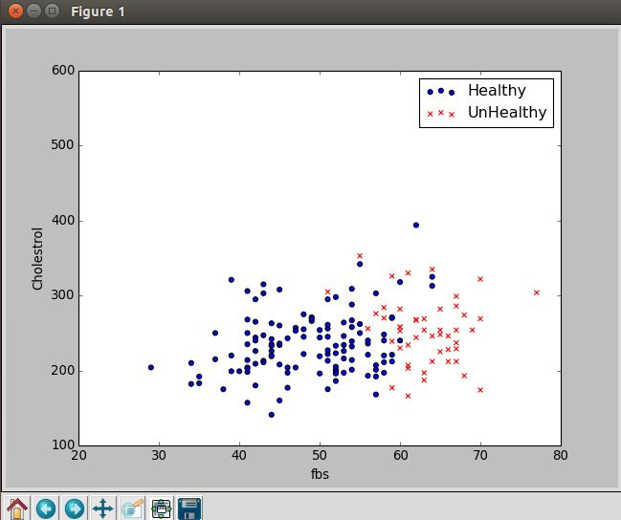

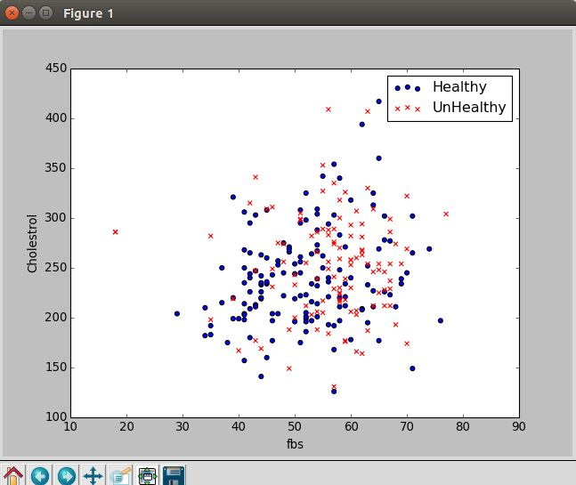

**HoloLens:**

We have implemented the basic origami with gaze, gestures, voice command and installed it to Microsoft HoloLens. Following screenshots corresponds to the implementation part of the application.

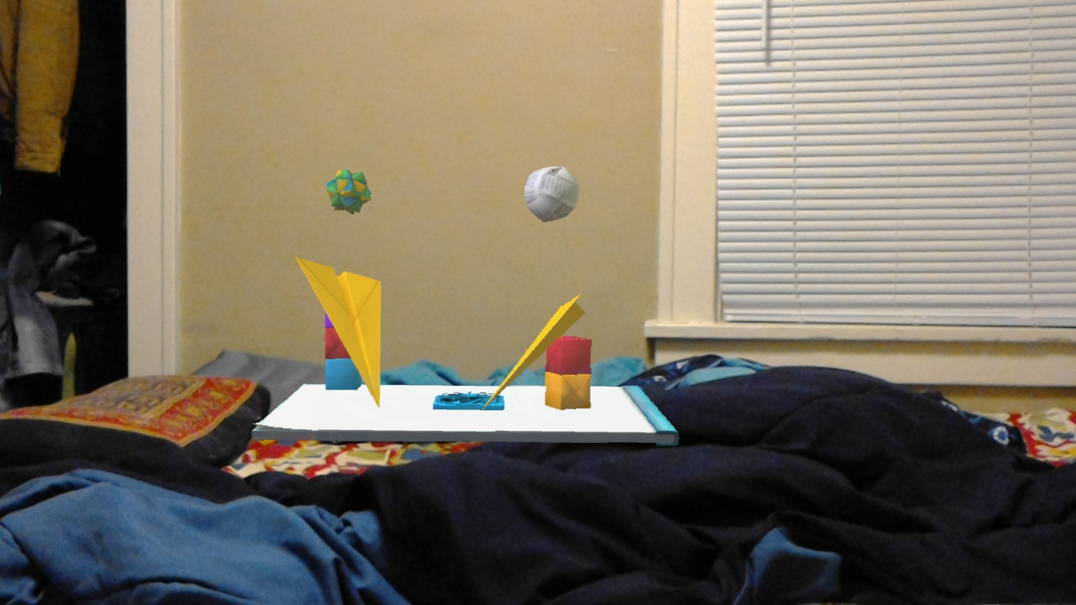

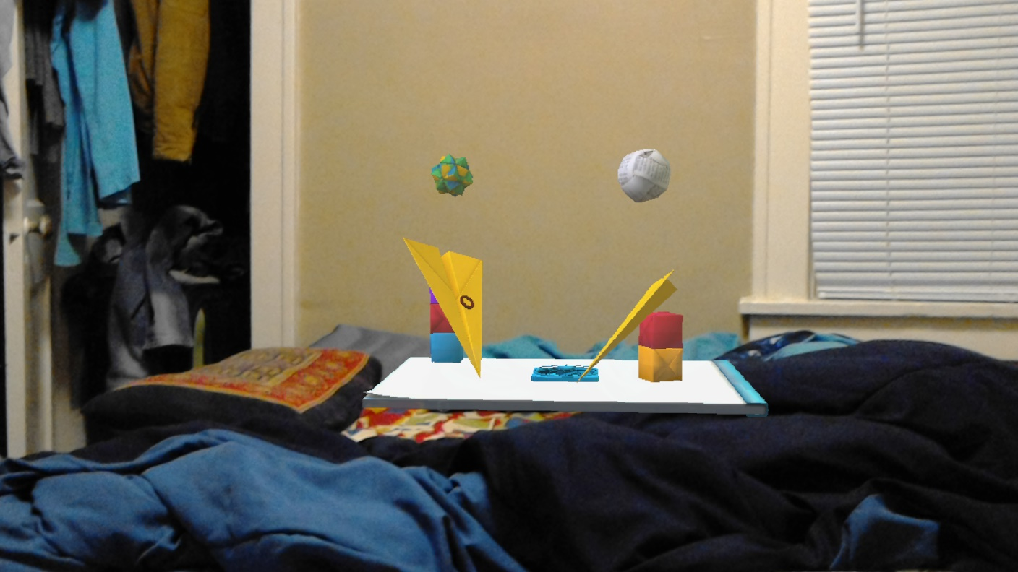

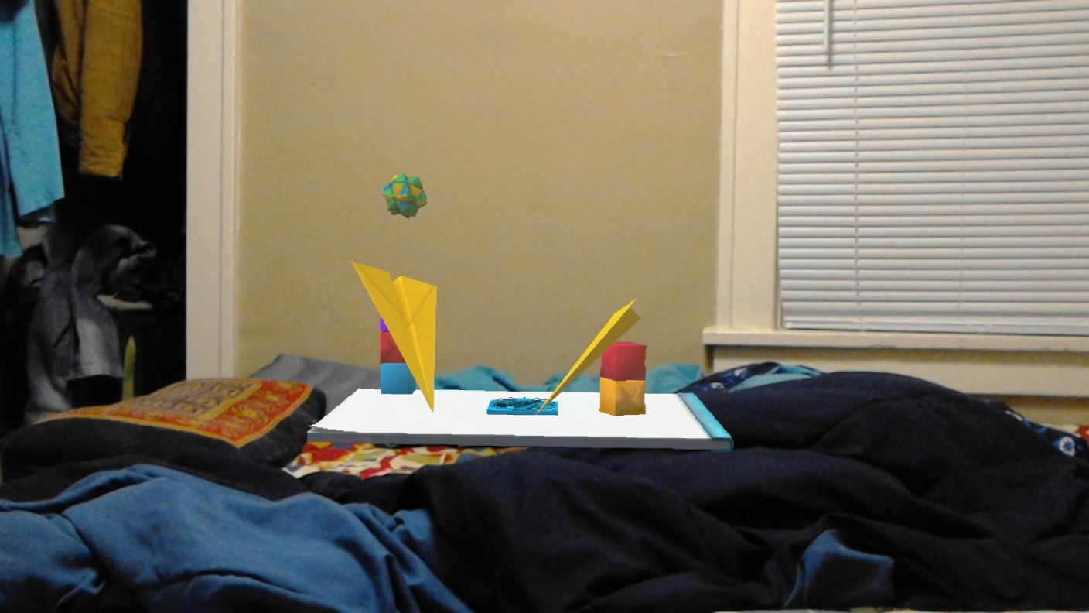

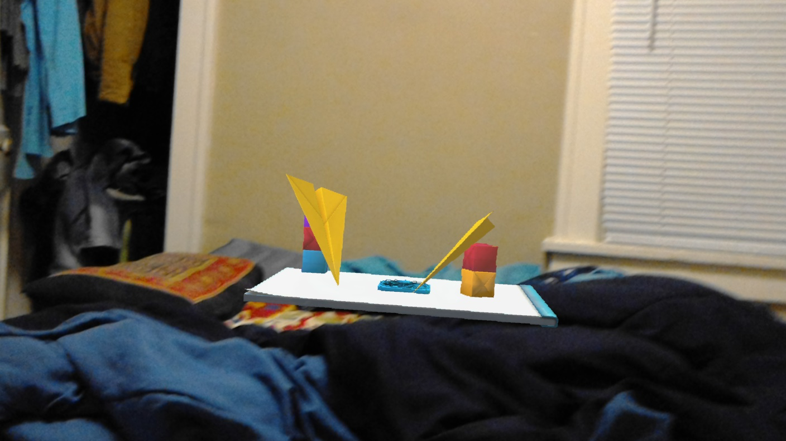

We have also installed a basic heart model to the HoloLens.

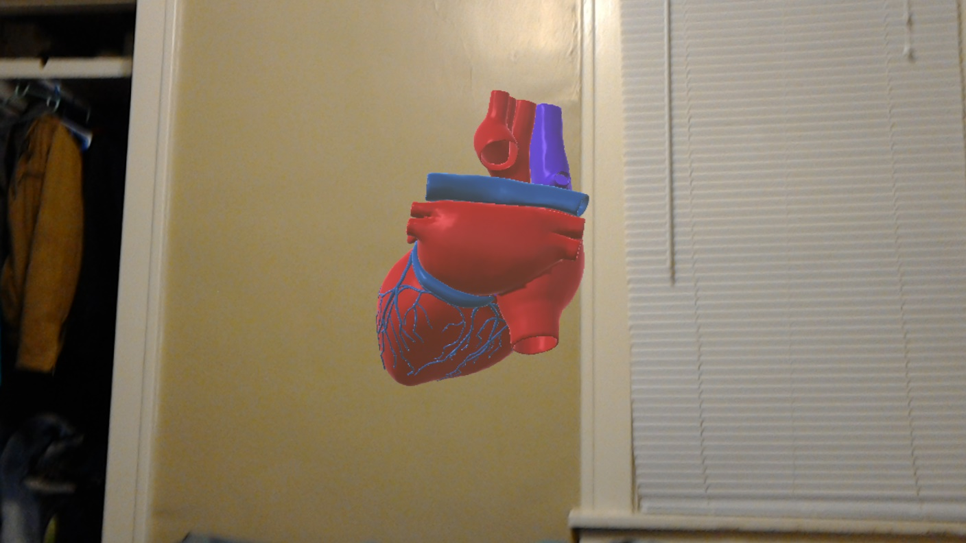

**Phase 2 for HoloLens:**

In this phase for HoloLens, we implemented the gaze feature and direction feature for the heart model which was developed in previous phase.

Below screen shots show us the gaze option with solid white dot and direction with the arrow symbol.

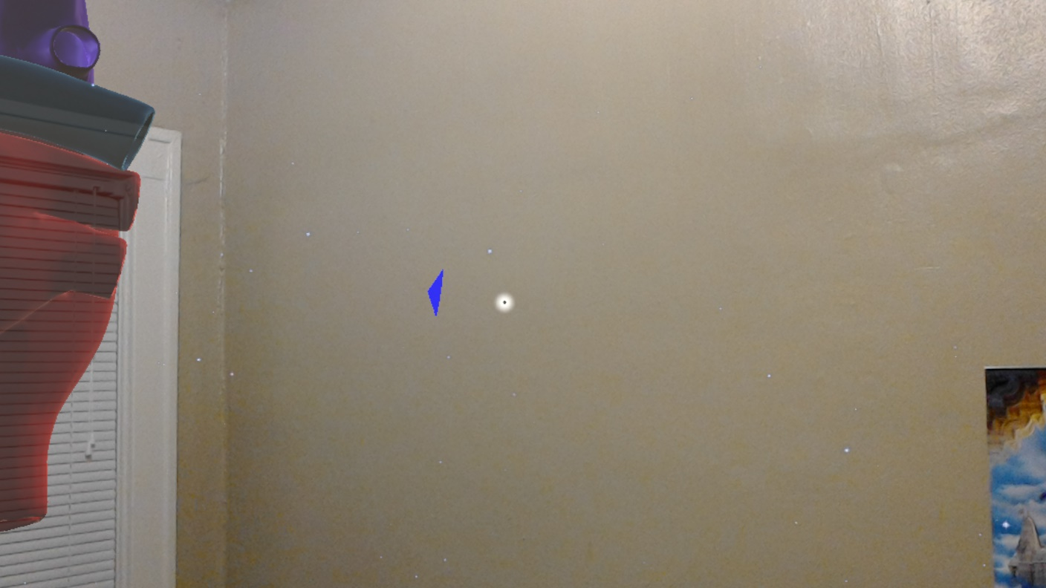

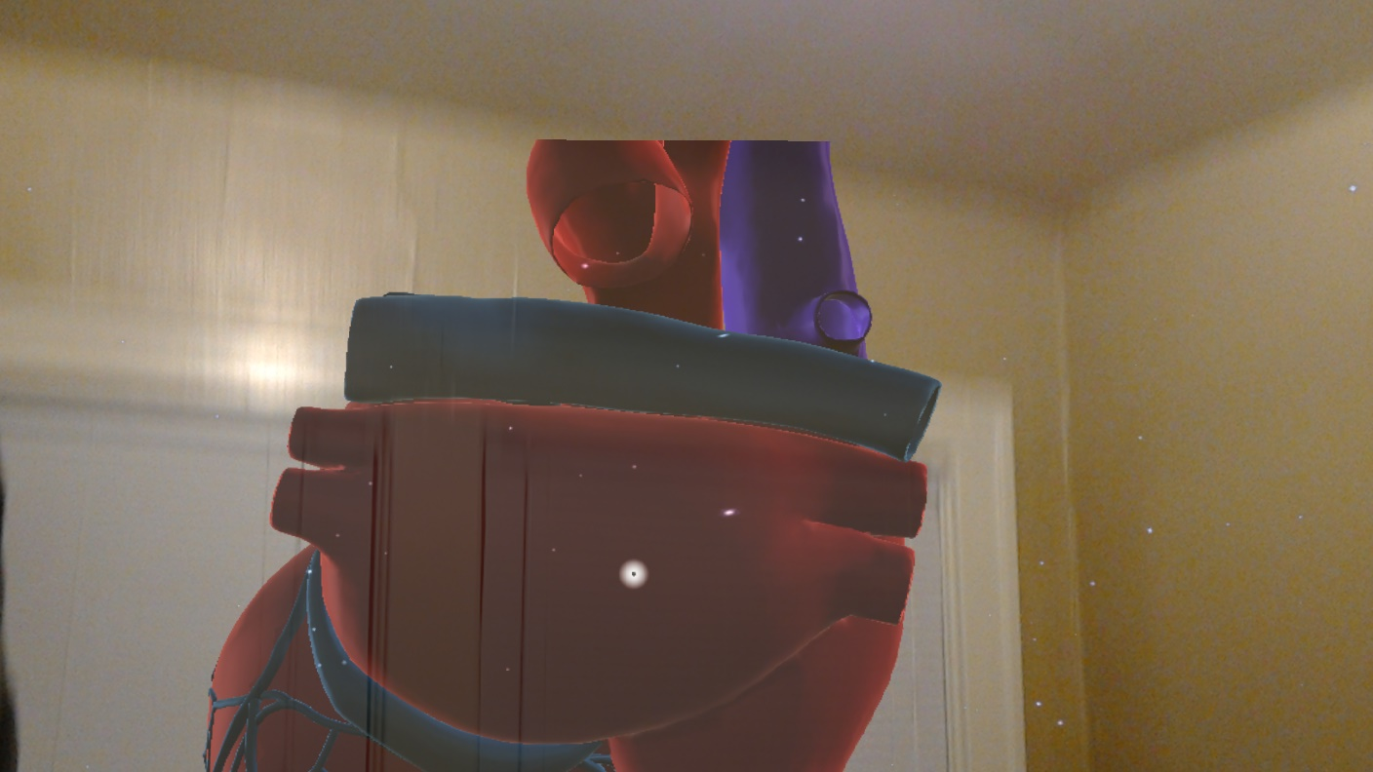

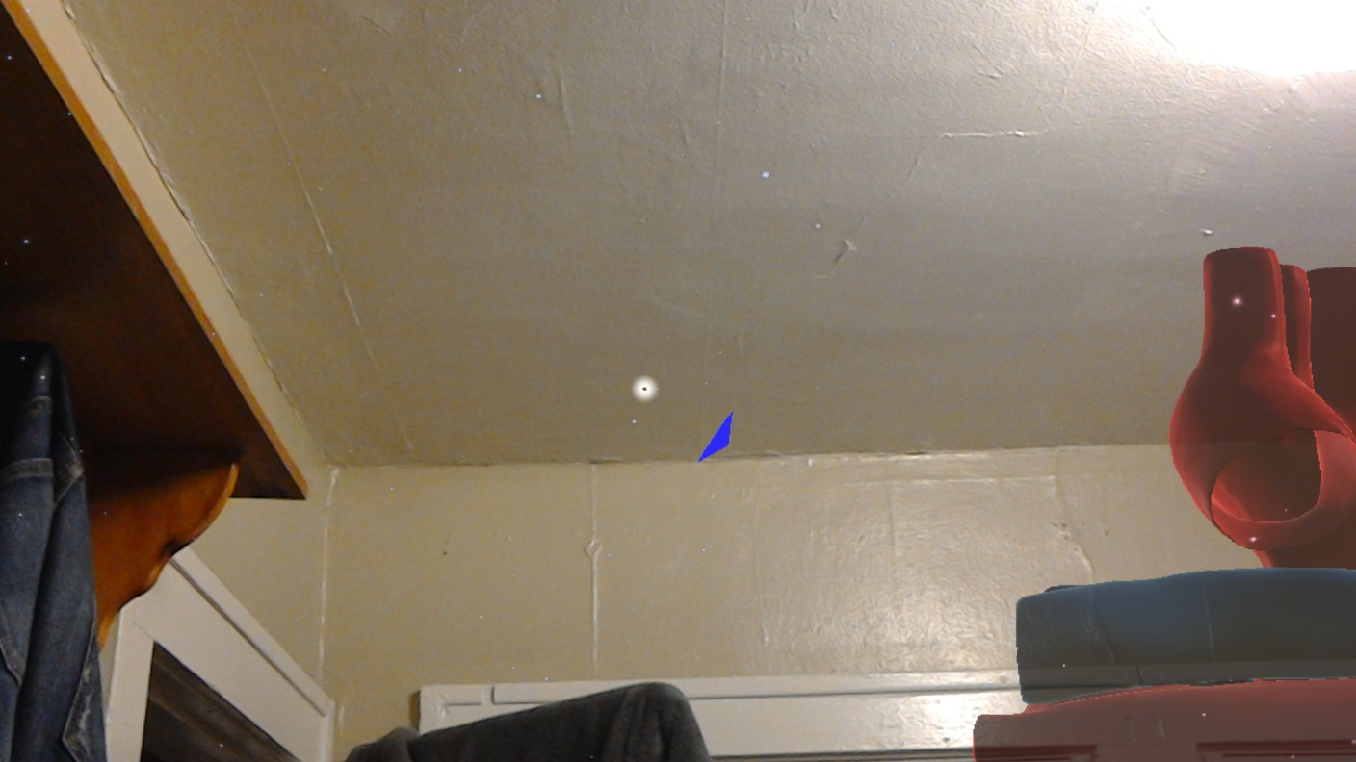

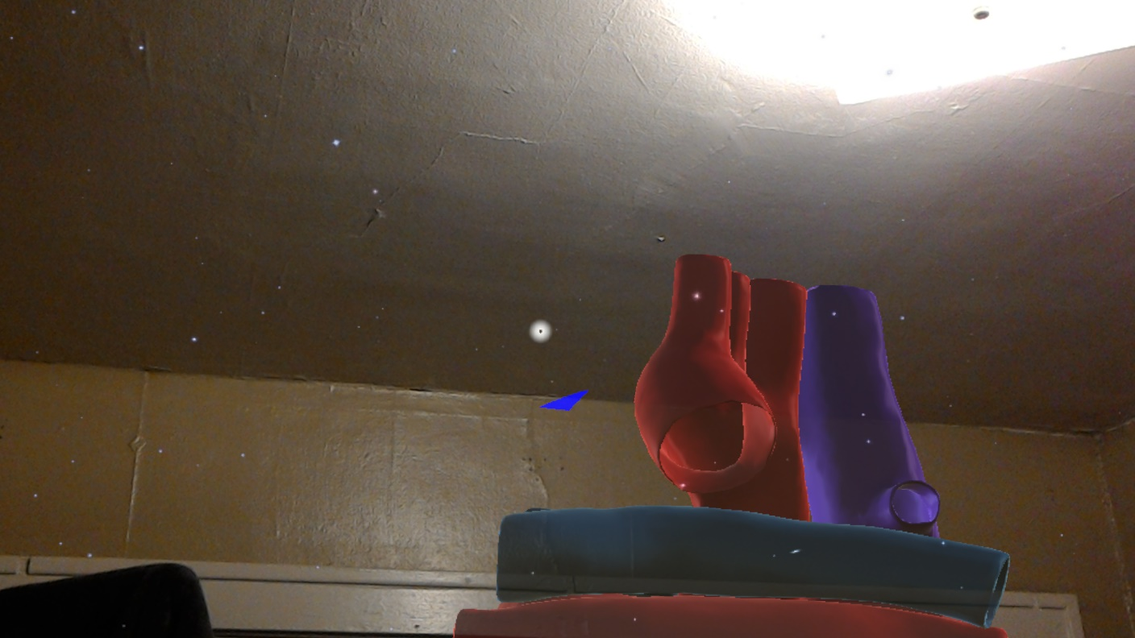

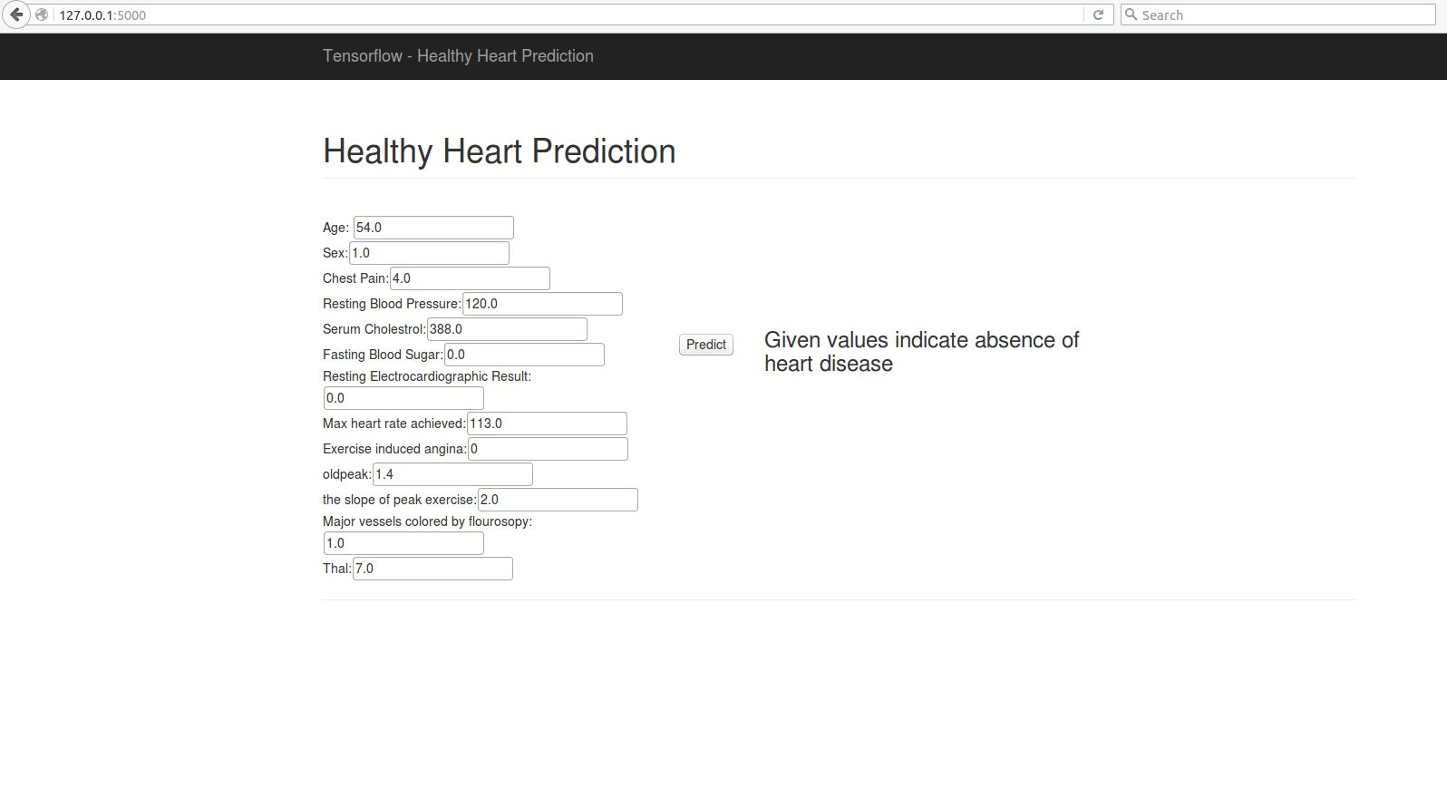

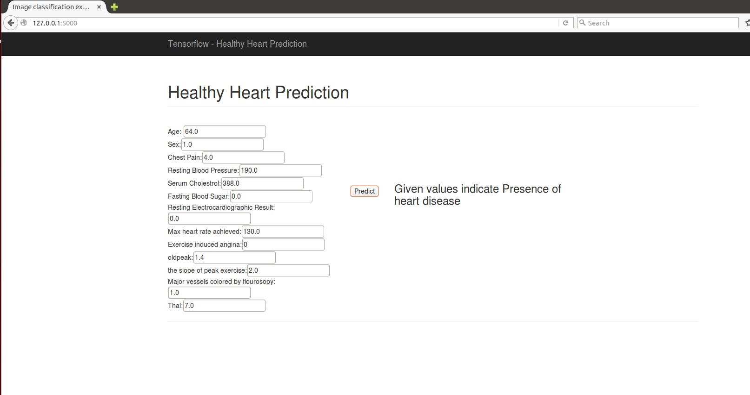

**Project Management**

**Work Completed:**

* Created Origami 3D model in Unity 3D
* Developed the basic Hologram model ‘Origami’ to the Microsoft HoloLens
* Added interactions to the Origami model by using c#.net
* Developed a basic human heart model and installed it to HoloLens
* Extracted the heart data from the Fitbit to excel sheet
* Added directions to the heart model.
* Implemented Linear and Logistic regression for the dataset collected.
* Implemented Classification using Deep Neural Network
* Created the web application to classify the heart status

**Contributions:**

* Sri Sai Narayana Ram Gopal Mangena – 50%
* Achyuth Reddy Nalamadgu – 50%

**Bibliography**

* <https://www.biodigital.com/developers>
* <https://www.eonreality.com/portfolio-items/virtual-anatomy-simulationv>
* https://developer.microsoft.com/en-us/windows/holographic/holograms_101
* <https://github.com/orcasgit/python-fitbit>
* <https://github.com/bfetler/coronary_disease>
* http://blog.mr-but-dr.xyz/en/programming/fitbit-python-heartrate-howto/
* <http://www.medpagetoday.com/practicemanagement/informationtechnology/59072>
* <http://anatomy4d.daqri.com/>
* <http://journals.plos.org/plosone/article?id=10.1371/journal.pone.0091276>
* [http://www.acculvein.com/home/](http://www.accuvein.com/home/)
* https://developer.microsoft.com/en-us/windows/holographic/documentation